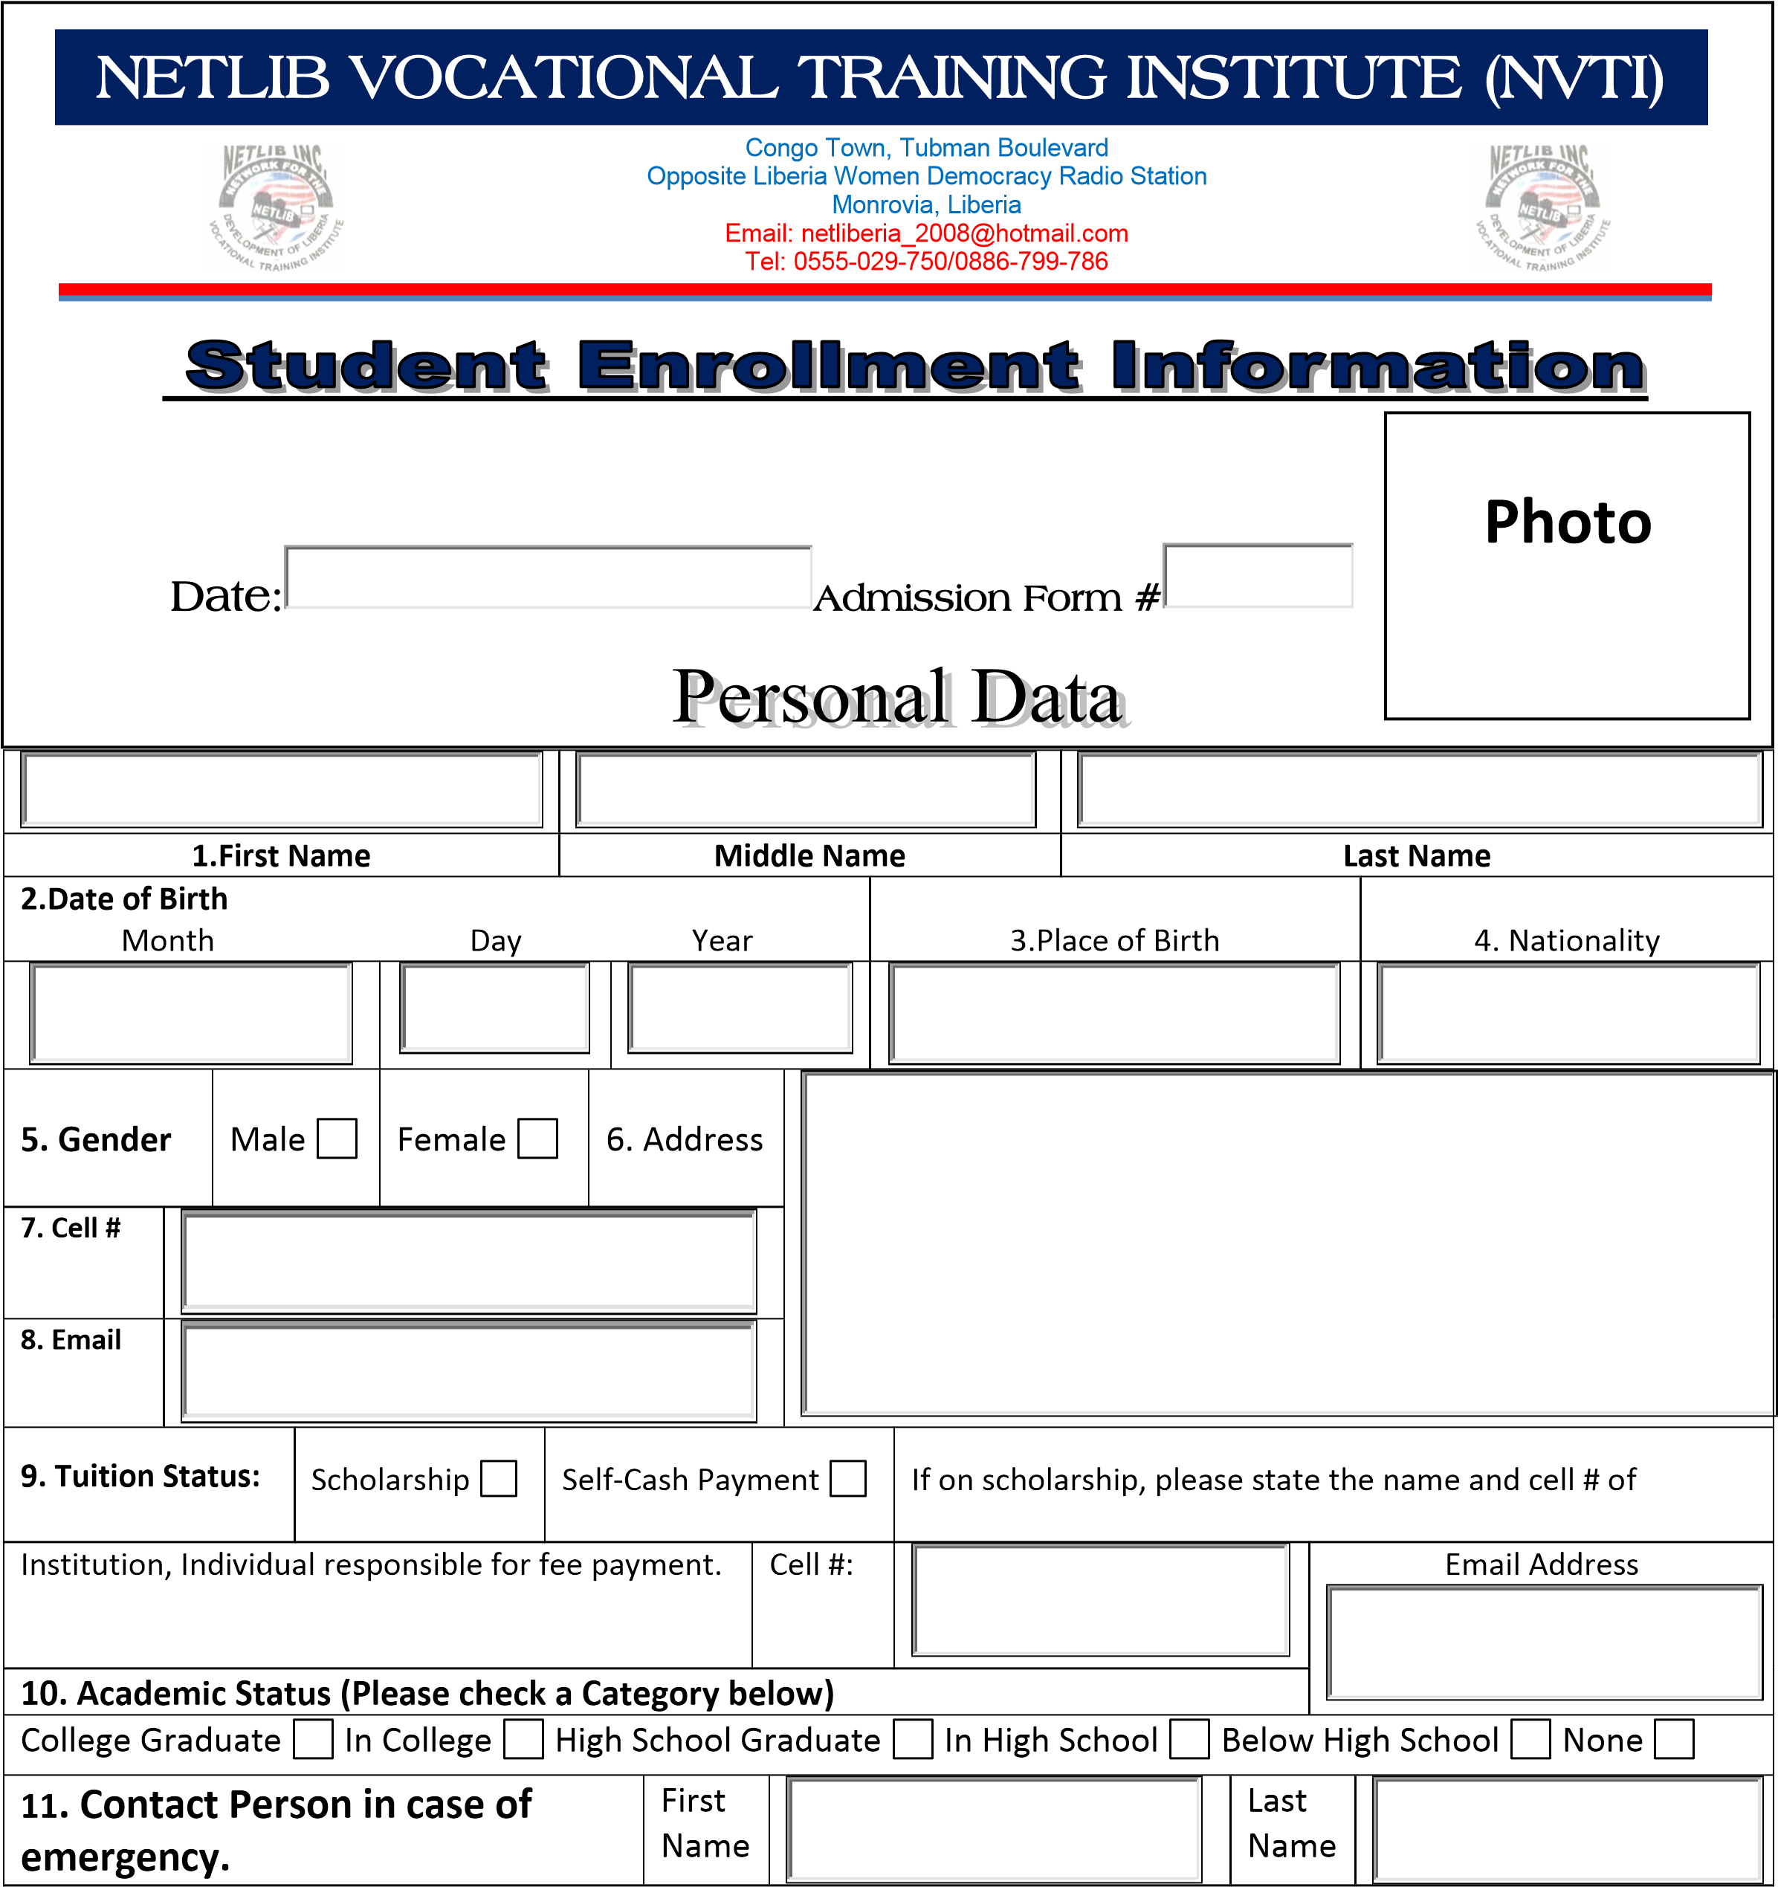

Tubman Boulevard, Oldest Congo Town

 Opposite Congo Town Satcom Television

Phone: +231-886677938/0777086164

We train students in becoming professionals in high demand career… we do this by creating pathways to employment

